1. ASP.NET **MVC Filter** is a custom class where you can write custom logic to execute before or after an action method executes. **Filters** can be applied to an action method or controller. 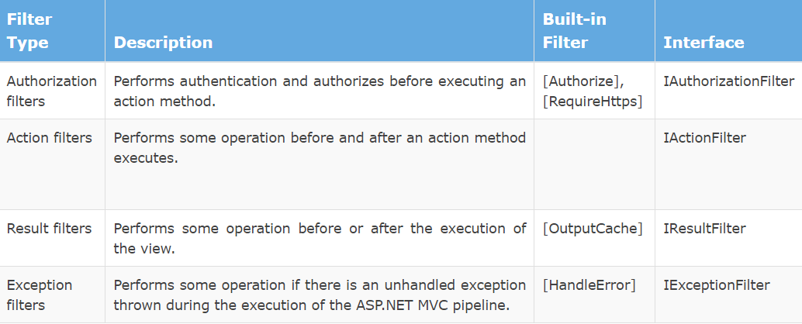
2. what is the difference between ado.net and linq  
   **ADO.NET** is the low level access to your database (ie you send SQL statements and get resulsets). **Linq to SQL** allows to expose data as .NET objects and is only for SQL Server. It is deprecated and replaced by Linq To Entity Framework which is more general (and that still uses ADO.NET behind the scene).  
   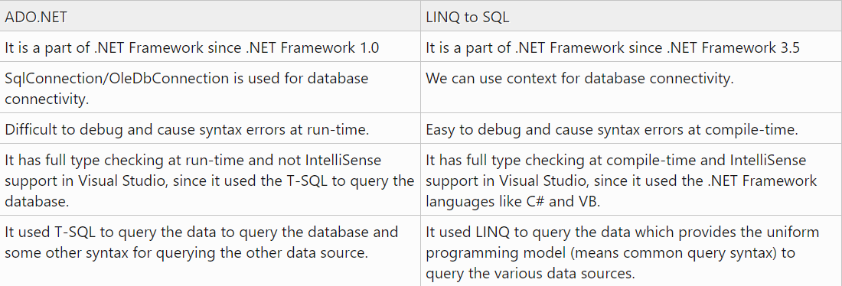
3. **Dependency Injection** is a technique whereby one object supplies the dependencies of another object.

مثلا عندي بروجيكت بتعامل مع اكتر من داتا بيس   
sqlServer and oracle and mysql  
ف بعمل   
parent class call DB  
and create 3 child class for mention database   
ف لما بدي انادي كلاس معين بحكي  
Db obj = new sqlServer();

1. **Polymorphism:** It’s process allow us called function from child class through parent reference object.
2. **Override:** Process make ability re-write function in the child class with same name same parameter but in different way (another code)